22.07.2025 – MONGO DB ASSIGNMENT

STEP – 1

Install Mongo DB

In the environment variables add the Mongo DB folder path and click “ok”

Verify by “mongod –version” in command prompt

STEP – 2

Install Mongo DB Shell

Verify by “mongosh” in command prompt

COMMANDS:

1. Show dbs – To view all the db present there
2. Use mongdb – To use mongdb
3. db createCollection("user") – To create a collection in the mongdb database
4. show collections – To view all the collections
5. db.user.insertOne({userid:1,product:"smartphone",quantity:100,place:"chennai"}) – To insert one value
6. db.user.insertMany([{userid:3,product:"cycle",quantity:20,place:"mumbai"},{userid:4,product:"bike",quantity:10,place:"bangalore"}]) – To insert many values at the same time
7. db.user.find({userid:1,place:"chennai"})

db.user.find({userid:1},{place:"chennai",quantity:10})

db.user.find({place:bangalore"}) – To view the datas

1. db.user.updateOne({product:"bike"},{$set:{place:"manali"})

db.collection.updateMany()

db.collection.replaceOne() – To update the values

1. db.user.deleteOne({quantity:30})

db.collection.deleteMany() – To delete the values

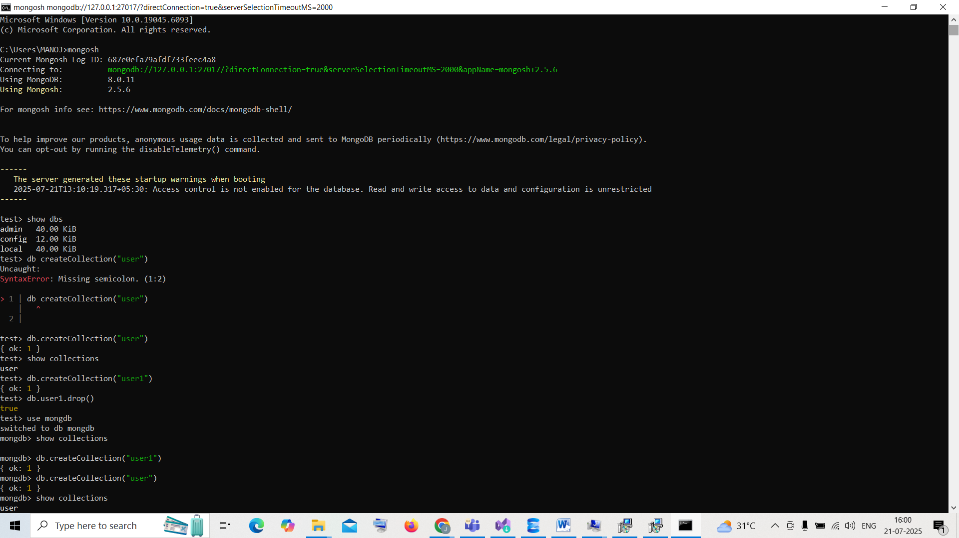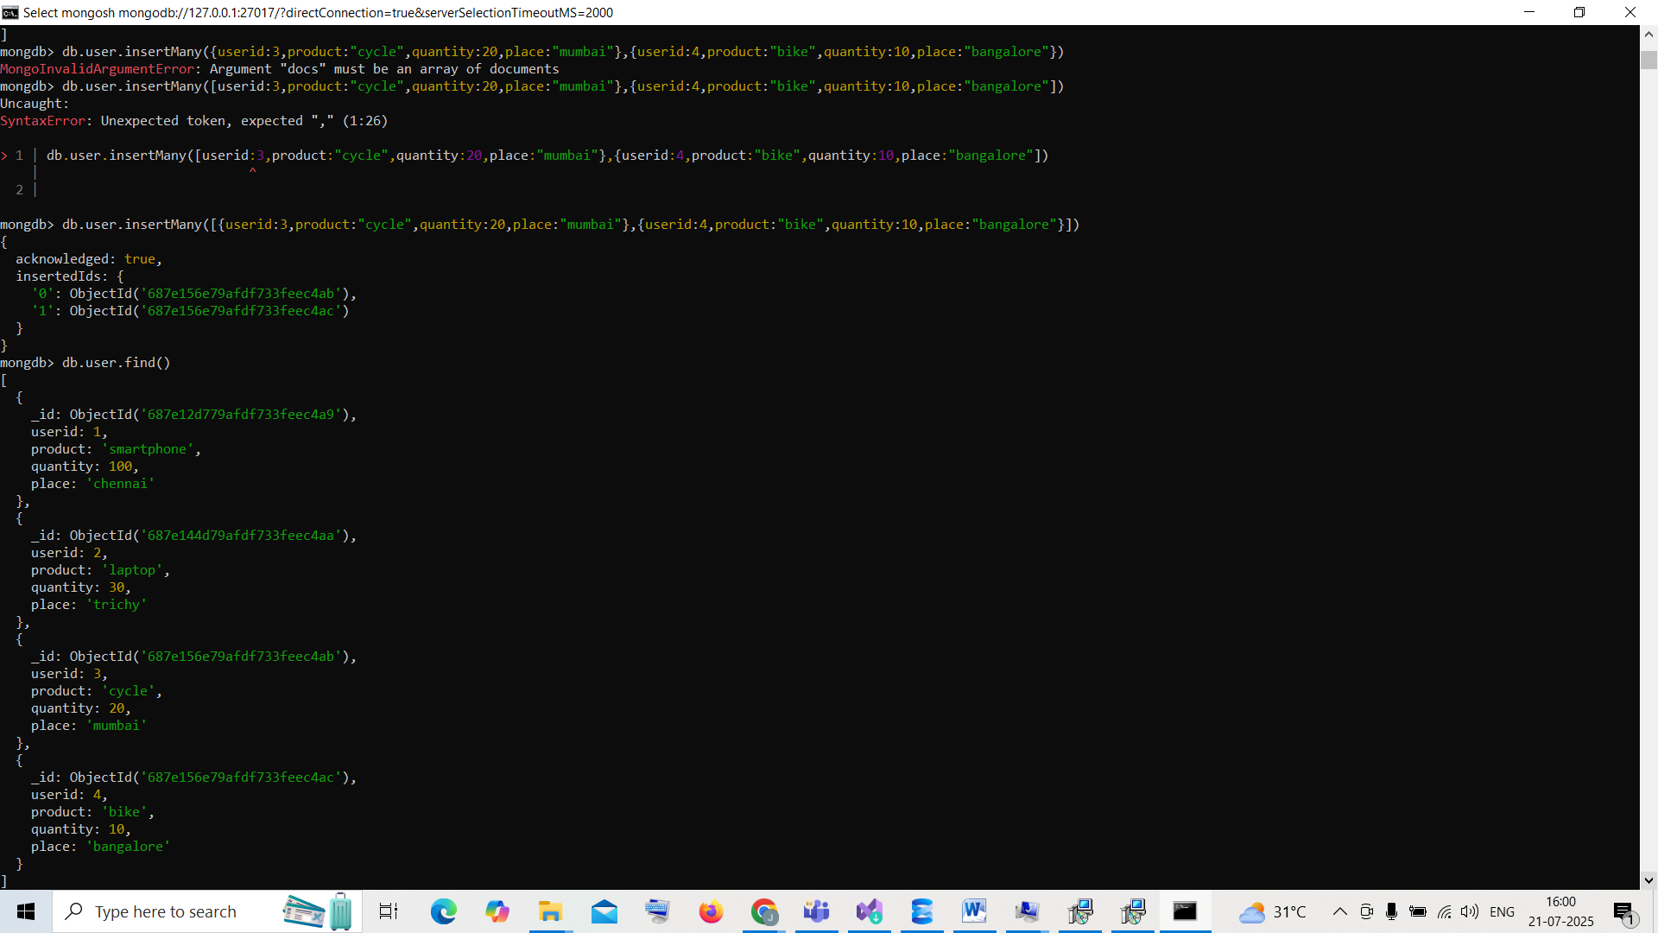

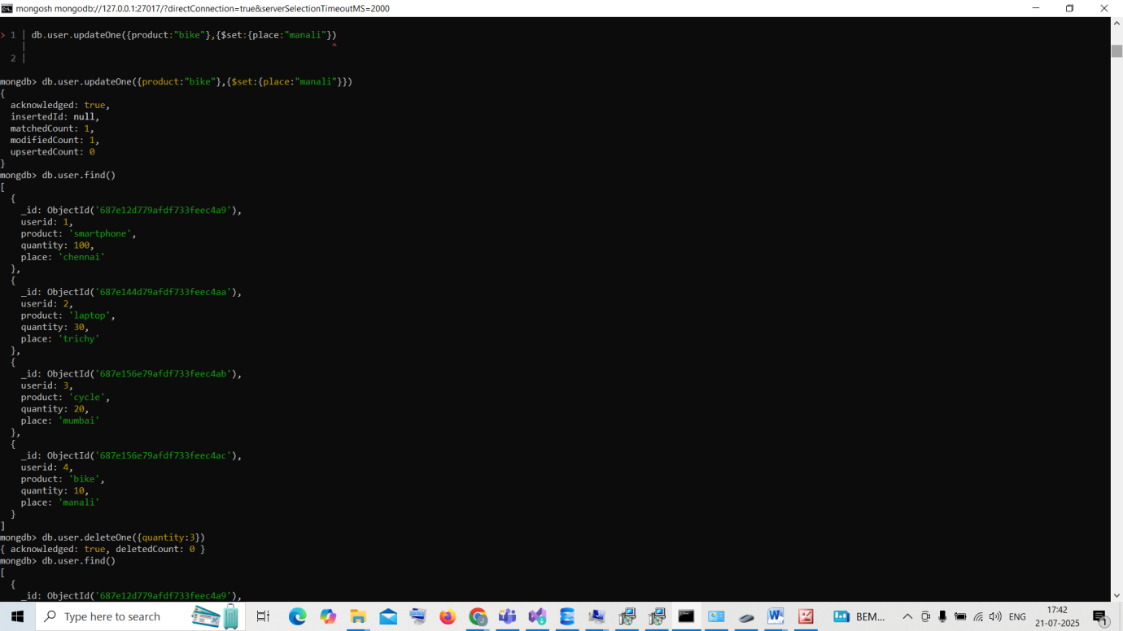

► Create Operations

Create or insert operations add new documents to a collection. If the collection does not

currently exist, insert operations will create the collection.

► Read Operations

►Read operations retrieves documents from a collection; i.e. queries a collection for

documents

► Update Operations

Update operations modify existing documents in a collection.

► Delete Operations

Delete operations remove documents from a collection.

